Marjorie Crowell

P A 397C: Data Management and the Research Life Cycle

May 10, 2019

**How Abortion Provision, Health Care Coverage, and State Factors can Predict the Number of Crisis Pregnancy Centers in a State**

***Introduction***

Crisis pregnancy centers are organizations which operate to target people with unintended or crisis pregnancy centers to dissuade them from choosing abortion. They typically do this through directed options counseling, where counselors may try to persuade the person considering their options by referencing links between abortion and adverse mental or physical health effects – links which have been scientifically disproven.[1] They may also provide such services as referrals for childcare or adoption services, some material resources for childcare such as diapers, and may also provide some medical services such as ultrasounds or pregnancy testing.[2] CPCs often use advertisements to reach potential clients such as billboards, web-based advertisements, or their websites, but these sometimes suggest that the facility may provide medical services or even abortion services.[3] CPCs have been a source of controversy because their counseling involves bias and because of the misinformation that may be involved in their counseling or advertisements. In addition, some states, including Texas, have directed some public funding to crisis pregnancy centers, which is also quite controversial.[4]

There has been a lot of research and writing on crisis pregnancy centers. Some of the literature available is empirical studies on the quality of care provided by the center or centered around the clients. Much of the research around crisis pregnancy centers has revolved around the quality of care provided. Some researchers have looked at the accuracy of the information provided at such locations. Bryant-Comstock et al analyzed CPC websites for the accuracy of sexual health information and found much of it to be inaccurate or misleading.[5] Tsevat et al conducted a mystery client survey at a random sample of 55 CPCs and found that many purposed their facility to provide direct medical care despite the fact that only one provided such services; the researchers also found that many of the locations gave overestimates of the danger of abortion and counselors at a majority of site visits expressed judgment about the mystery client’s decision.[6] Other researchers have focused on what services clients seek and whether clients are satisfied with the quality of care provided.[7]

Crisis pregnancy centers sometimes open near abortion providers and may use language that makes it difficult for potential patients to tell whether or not the clinic provides abortion.[cite] Some crisis pregnancy centers that operate near abortion providers have adopted names similar to the abortion provider, which may cause people seeking an abortion to go to a crisis pregnancy center by accident instead, which can cause confusion and delay care.[8] A 2010 study by Yuengert and Fetzer focused on the locations of abortion providers and CPCs in California found that the number of abortion providers in a location had no independent effect on the number of abortion providers.[9]

In recent years, restrictions on abortion providers have increased in number and scope[10] and the number of abortion providers has sharply decreased.[11] People in 27 cities live more than 100 miles away from an abortion provider.[12]

Crisis pregnancy centers are typically not medical facilities and so are not regulated in the way that other facilities are. Many states and advocacy organizations have attempted to regulate crisis pregnancy centers in recent years but often these efforts have run into legal issues, particularly surrounding the right to free speech of the facility and their employees.[13] Some states and cities have passed legislation requiring CPCs to post signs declaring that they do not provide abortion services nor referrals for abortion services; this type of legislation in Austin, TX, New York, and Maryland has been struck down by federal courts citing violations of freedom of speech.[14] California’s Reproductive FACT Act, passed in October 2015, required CPCs to inform their clients that the state offers free or low-cost access to comprehensive family planning services, prenatal care, and abortion for eligible women; this law was struck down by the courts for similar reasons.[15]

On the other hand, abortion been the focus of a lot of state-level regulations, particularly in recent years. The Guttmacher Institute found in 2017 that one in three of the state-level regulations on abortion passed since Roe v. Wade guaranteed the right to abortion in 1973 were enacted in the previous seven years.[16] Ted Joyce, a health economist, discussed in a 2011 article for the *New England Journal of Medicine* the idea that some abortion restrictions fall on the “supply side,” or on abortion providers, while others fall on the “demand side,” or on those seeking abortion.[17] Abortion restrictions have caused many facilities to close,[18] causing issues for those in communities without abortion providers. State regulations vary in their focus and measure. Some restrictions focus on the provision of abortion, aiming at abortion providers themselves. Some states require facilities to adhere to regulations that restrict the way facilities can be constructed, such as requiring them to adhere to the restrictions around ambulatory surgical centers.[19] Other states may restrict the methods that may be used to induce abortion or require providers to have admitting privileges at local hospitals, a hurdle that may be insurmountable if local hospitals are Catholic owned or otherwise unsupportive of abortion providers. The U.S. Supreme Court, in its *Roe v. Wade* decision, held that states may only constitutionally ban or restrict abortions after the point of fetal viability, except where necessary to preserve a woman’s life or health, but some states restrict abortion even further, despite the legal requirement to allow abortion until viability.[20]

Other state restrictions focus on those seeking abortion services. Some of these restrictions include requiring those seeking abortion to receive state-mandated counseling prior to being able to receive the procedure, or requiring them to have ultrasounds prior to the procedure (ultrasounds are not considered medically necessary before an abortion in the first trimester).[21] Some states require people to wait between seeing the provider and having the procedure (this can be anywhere from 24-72 hours, depending on the state’s law).[22] States may have special restrictions on minors, requiring them to have a parent consent to their decision or go through a process known as judicial bypass to allow them to move forward without getting a parent’s consent.[23]

Some states restrict how abortions may be funded. The Hyde amendment, adopted every year since 1976, prohibits federal funds from paying for abortion except in the case of life endangerment or if the pregnancy arises from incest or rape.[24] Medicaid is a public insurance program funded jointly by federal and state public monies.[25] The Hyde amendment prohibits Medicaid programs from using federal funding to pay for abortions outside of these exceptions, but states can choose whether or not to follow.[26] Some states follow the Hyde amendment for state Medicaid funds, while others allow for state Medicaid funds to pay for abortion that do not meet these restrictions.

Restrictions on abortion, whether on providers or on those seeking abortions, restrict the ability of people within the state to access comprehensive reproductive health care. On the other hand, crisis pregnancy centers, which have been found to provide misinformation to those seeking abortion, are often unregulated. The research question this analysis seeks to address is as follows: how is the number of crisis pregnancy centers in a state affected by abortion provision within the state and health care coverage within the state, controlling for political and demographic factors? The working theory behind my analysis is that crisis pregnancy centers open in response to abortion providers in the state, and may also be spurred to open by a concentration of donors, politicians, or voters in a state who may also be unfriendly toward abortion provision or other health coverage within the state.

***Methods***

***Data Sources***

*Crisis Pregnancy Centers*

The data on crisis pregnancy centers by state come from a dataset by Reproaction.[27] Reproaction, an organization dedicated to creating a more favorable climate for abortion rights and reproductive justice, compiled the dataset to include all discoverable crisis pregnancy centers operating nationwide.[28] The dataset is open-source and available on the Reproaction website.

*Abortion Provision*

This analysis operationalizes abortion provision within the state by looking at the number of aboritons provided within the state, the number of abortion providers within the state, and regulations on the provision of abortion within the state. In order to measure abortion provision within the state, this analysis uses the number of abortion providers within the state, the number of abortions provided within the state, and whether or not certain regulations on abortion providers and abortion patients are in place and enforced within the state.

The data on the number of abortion providers within the state and the number of abortions provided within the state both come from the Guttmacher Institute’s National Provider Census. As part of this research, researchers at Guttmacher compile records of all of the facilities and individuals who are providing abortions and take a census of them to find the number of abortions provided within the country in a year.[29] This data is unique in its coverage and source: some state health departments report the number of abortions provided within the state to the Centers for Disease Control and Prevention, but not all states report this data and not all providers within states report the information to their respective health departments.[30] This analysis will use Guttmacher’s data on the number of abortion procedures and providers by state in the most recent year for which data are available, 2014.[31]

The data on abortion regulations come from datasets available on the Kaiser Family Foundation website. The datasets use data from the Guttmacher Institute. In order to validate the datasets, I confirmed the data against the Guttmacher website. The abortion regulations I am using in this analysis include whether or not states have restrictions on clinics’ structural standards similar to ambulatory surgical centers, whether or not states restrict abortion past a certain point in pregnancy, whether states require ultrasounds before an abortion, whether private insurance plans in the state or states’ health insurance marketplaces restrict abortion coverage, whether states have a mandatory waiting period prior to abortion services, whether states follow the federal standard and allow Medicaid to fund abortions only for cases involving life endangerment, rape, or incest, whether states require parental consent for minors seeking abortions, whether states have a so-called “partial birth” abortion ban, and whether states have laws in place banning abortion (from prior to the *Roe* decision) or expressing the intent to limit abortion to the maximum extent permitted under the law. I am also looking at whether state law protects the right to abortion.

Some states have regulations in place which have been enjoined by court orders or are similarly non enforceable: I included a law on the books only if the law was in place and enforced within the state, with one exception. In the case of state policy banning abortion existing from prior to the *Roe* decision or expressing the intent to limit abortion to the maximum extent permitted under the law, I included these laws although they are not enforced.

*Health Care Coverage*

I operationalized health care coverage within the state by looking at the percent of people within the state who do not have health insurance and whether or not the state has expanded Medicaid. Prior to the Affordable Care Act, Medicaid was only available to children, parents, people with disabilities, and some people over age 65, although states had some discretion with regard to income eligibility levels. The ACA offered states the option to expand eligibility for Medicaid to individuals with incomes up to 138% of the federal poverty level, offering federal funding to cover the costs of newly eligible enrollees for a set number of years.[32] So far, 37 states have expanded Medicaid, and studies have found improved outcomes due to Medicaid expansions.[33] The data on whether or not the state has expanded Medicaid are from a dataset available from the Kaiser Family Foundation.[34] The data are current as of the end of April, 2019.

The data on people within the state who do not have health insurance come from a dataset uploaded to Kaggle by the U.S. Department of Health and Human Services.[35] The dataset gives the percent of people without health insurance in 2010 by state, the percent without health insurance in 2015, and the change in this coverage from 2010-2015, as well as a few other variables, to look at the effects of the Affordable Care Act. This analysis uses the percent of people without health insurance in 2015 to look at health care coverage within the state.

*Political and Demographic Factors*

In order to control for political and demographic factors within the state, this analysis uses voting behavior in the state and state population. In order to analyze state voting behavior, I constructed a simple dataset with each state coded as Democrat or Republican for 2012 and 2016, using data from the Federal Elections Commission on the 2012 and 2016 presidential elections. States’ voting behavior for 2012 was highly correlated with voting behavior for 2016, with only five states’ results different in 2016 than in 2012. All of these states voted Democratic in 2012 but Republican in 2016. Because the data on CPCs and the data on abortion regulations are within the last few years, I have chosen to use states’ voting behavior in 2016.

The data on state population come from a dataset available from Kaiser Family Foundation, using population numbers from 2017. The data on KFF come from the U.S. Census Bureau’s American Communities Survey.

*Selection of Variables*

*Analysis*

This research ties together data from many different sources, which I will discuss below, to build upon prior data collection work. I cleaned all datasets in Python using pandas to remove columns with data not used in the analysis, empty rows, and rename columns to be more informative. I also removed rows with U.S. total or aggregate numbers, because my analysis focused on the state level, and not all were uniform in their reporting (some included territories that others did not, and some presented an aggregated average whereas others were totals). The CPC database from Reproaction included the city, state, and zip all in the same cell; for analysis, using pandas and Python, I separated out the state for each facility and then reorganized the dataset so that it was organized by state and each state was associated with the total number of unique CPC facilities within that state. I then used Python and pandas to merge together all datasets on the state variable.

In Stata, I did a bit of final cleaning and recoded all dummy variables to appear as coded 0 or 1. In the case of regulations on abortion, 0 indicates that such a law is not in place or is not enforceable (the law is enjoined by a court, in most cases). 1 indicates that a law is in place and enforced. The exception to this is in the case of state law around abortion: some states have a ban on abortion which predates the Roe v. Wade decision, and others have regulations which express an intent to restrict abortion to the earliest extent possible. In these instances, these laws are not enforceable, but I used the presence of such a law on the books in analysis, because my theory relates to the combined atmosphere of abortion regulations as having an influence on the number of crisis pregnancy centers.

In selecting variables for regression models to address my theory, I first had to select out variables which were highly correlated with one another. States’ voting behavior in 2012 and 2016 were highly correlated, so I chose to use voting behavior in 2016 as it was closer to the date for the rest of the data used in the models. A study by Blank, George, and London, in 1996, found that the number of abortion providers in a state is a determinant of the abortion rate within the state.[36] Similarly, I found that the number of abortion providers was highly positively correlated with the number of abortions provided by state; in order to parallel the dependent variable, I chose to use the number of abortion providers as both represent facilities, rather than comparing patients served with the number of facilities. Each abortion regulation was somewhat positively correlated with state voting behavior in 2016, and the composite score of regulations was extremely correlated with state voting behavior.

*Mathematical Models*

In model number 1, I looked only at the relationship between the number of crisis pregnancy centers and abortion providers in a state, controlling for state population, as states with a higher population will likely have more of both types of facilities.

Model number 2 looks at the relationship between the number of crisis pregnancy centers and providers in a state, controlling for both state population and voting behavior, in order to look at whether adding voting behavior better predicts the number of CPCs in a state. In model 3, I looked at whether including the percentage of people uninsured in 2015 to model 2 helped better predict the number of CPCs.

For model number 4, I added in all of the regulations to model number 3. Abortion regulations in the model all acted as dummy variables (whether or not the state had the regulation in place and enforceable, except for the restrictions from before Roe), which had the effect of canceling one another out. In order to operationalize anti-abortion sentiment in a state, I constructed a composite score that totaled the number of abortion regulations within a state, ranging from 0 to 8. In model 5, I looked at the relationship between number of CPCs, number of providers, rate of people uninsured, and the score of total abortion regulations, controlling for voting behavior and state population. For model number 6, I wanted to look at only regulations targeting abortion providers, to see if crisis pregnancy centers were opening more in response to abortion providers in a state, so I used a composite score which only totals the restrictions on abortion from the supply side.[37] I wanted to isolate regulations which seek to dissuade people from receiving abortions, whether by introducing delays or preventing them from obtaining abortion services, so I created another composite score that totaled the number of regulations on abortion on the demand side. For model number 7, I looked at the relationship between the number of crisis pregnancy centers, providers, uninsured, and demand-side abortion regulations, again controlling for state population and voting behavior.

I also wanted to look at whether states’ supportive policies around abortion had some effect. For my final model, number 8, I used the total composite score as model number 5, but subtracted from the score for states which had a policy supporting the right to abortion.

*Analysis*

I used Stata to do the final analysis, performing an ordinary least squares regression to analyze the relationship between abortion provision in a state, health care coverage in that state, and crisis pregnancy centers in that state, controlling for political and demographic factors within the state. Within Stata, I created a composite variable to capture the number of regulations on abortion and abortion providers within the state. States received a score which reflected how many of the abortion regulations I used in the analysis were in place and enforced within the state. This composite score ranged from 0, for states without regulations on abortion, to 8, the states with the most restrictions.

In order to look at the relationship between crisis pregnancy centers and the indicators from my research question, I used a few different models. All of these are based on the theory that crisis pregnancy centers open in response to anti-abortion sentiment, or nearby abortion providers, or both.

***Data Management***

All of the data used in this analysis come from publicly available datasets. In order to manage the data, I saved all code, data, and output separately, with raw data files saved separately from working data files and merged data in another folder. All code is annotated and available via my GitHub, as is my final dataset. For more on data management for this project, see Appendix C (“Data Management Plan”).

***Results***

Robustness Check

***Limitations***

One issue with this model is in the difficulty in validating the number of crisis pregnancy centers by state. The data from Reproaction includes data for 2,629 clinic locations, but some advocacy organizations estimate there to be over 3,500 locations nationwide: NARAL Pro-Choice America estimated there to be over 3,500 in 2017.[38] This could be an error, or it could be that facilities have closed in recent years, or it could be that the Reproaction database does not include all facilities nationwide. This model assumes that, if there are clinic locations missing from the database, they are not missing in a systematic way; however, if this is not the case, it may introduce bias into the results.

Another limitation of the model is that all data come from different years. While the number of abortions and providers referred to data from 2014 and the rate of people within a state without insurance came from data from 2015, the data on crisis pregnancy centers are current.

Similarly, another issue with this model is that it treats all aspects of the model as static. The number of abortion providers and crisis pregnancy centers in a state is not constant and may change from year to year. A state may have appealed an enjoined law and may be able to enforce it, or courts may have overturned laws that were previously enforceable. State legislatures may have introduced or repealed regulations in the time since the dataset was constructed.

***Discussion***

Since abortion is a time sensitive issue and crisis pregnancy centers may introduce further delays, it would be interesting to look at whether the number of crisis pregnancy centers affects abortion services in the state. It may be that the number of crisis pregnancy centers causes the abortions provided in a state to be further along in gestational age, or the number of self-managed abortions to be higher. Further research could look at the number of crisis pregnancy centers on these measures; however, as these data are highly sensitive, it is outside the scope of this paper.

Crisis pregnancy centers were also associated with higher rates of people in a state lacking health insurance. Further research could also look into whether there is an association between crisis pregnancy centers and poor health outcomes.

Furthermore, the measures in this research are very geographically specific; therefore, it would be interesting to look at these measures using spatial or geographic analysis. It would be interesting to see whether these effects differ based on how far a person is from an abortion provider or how many abortion providers and crisis pregnancy centers are within a certain distance of a person.

***References***

“Abortion Policy in the Absence of Roe.” Guttmacher Institute, March 14, 2016. https://www.guttmacher.org/state-policy/explore/abortion-policy-absence-roe.

“About Reproaction.” Reproaction. Accessed April 18, 2019. https://reproaction.org/about/.

Alliance Defending Freedom. “Austin LifeCare v. City of Austin.” Default. Accessed April 17, 2019. http://adflegal.org/detailspages/case-details.

———. “Pregnancy Care Center of New York v. City of New York.” Default. Accessed April 17, 2019. http://adflegal.org/detailspages/case-details.

Antonisse, Larisa, Rachel Garfield, Samantha Artiga Published: Mar 28, and 2018. “The Effects of Medicaid Expansion under the ACA: Updated Findings from a Literature Review.” *The Henry J. Kaiser Family Foundation* (blog), March 28, 2018. https://www.kff.org/medicaid/issue-brief/the-effects-of-medicaid-expansion-under-the-aca-updated-findings-from-a-literature-review-march-2018/.

Biggs, M Antonia, Brenly Rowland, Charles E McCulloch, and Diana G Foster. “Does Abortion Increase Women’s Risk for Post-Traumatic Stress? Findings from a Prospective Longitudinal Cohort Study.” *BMJ Open* 6, no. 2 (February 1, 2016). https://doi.org/10.1136/bmjopen-2015-009698.

“Bill Text - AB-775 Reproductive FACT Act.” Accessed April 17, 2019. https://leginfo.legislature.ca.gov/faces/billNavClient.xhtml?bill_id=201520160AB775.

Blank, R. M., C. C. George, and R. A. London. “State Abortion Rates. The Impact of Policies, Providers, Politics, Demographics, and Economic Environment.” *Journal of Health Economics* 15, no. 5 (October 1996): 513–53.

Bryant, Amy G., and Jonas J. Swartz. “Why Crisis Pregnancy Centers Are Legal but Unethical.” *AMA Journal of Ethics* 20, no. 1 (March 1, 2018): 269–77. https://doi.org/10.1001/journalofethics.2018.20.3.pfor1-1803.

Bryant-Comstock, Katelyn, Amy G. Bryant, Subasri Narasimhan, and Erika E. Levi. “Information about Sexual Health on Crisis Pregnancy Center Web Sites: Accurate for Adolescents?” *Journal of Pediatric and Adolescent Gynecology* 29, no. 1 (February 2016): 22–25. https://doi.org/10.1016/j.jpag.2015.05.008.

Cartwright, Alice F., Mihiri Karunaratne, Jill Barr-Walker, Nicole E. Johns, and Ushma D. Upadhyay. “Identifying National Availability of Abortion Care and Distance From Major US Cities: Systematic Online Search.” *Journal of Medical Internet Research* 20, no. 5 (2018): e186. https://doi.org/10.2196/jmir.9717.

Centers for Disease Control and Prevention. “CDCs Abortion Surveillance System FAQs,” January 16, 2019. https://www.cdc.gov/reproductivehealth/data_stats/abortion.htm.

Collaborative Group on Hormonal Factors in Breast Cancer. “Breast Cancer and Abortion: Collaborative Reanalysis of Data from 53 Epidemiological Studies, Including 83 000 Women with Breast Cancer from 16 Countries.” *The Lancet* 363, no. 9414 (March 27, 2004): 1007–16. https://doi.org/10.1016/S0140-6736(04)15835-2.

“Counseling and Waiting Periods for Abortion.” Guttmacher Institute, March 14, 2016. https://www.guttmacher.org/state-policy/explore/counseling-and-waiting-periods-abortion.

Duncan, Ian. “Federal Appeals Court Rules against Baltimore Law Requiring Disclosures at Pregnancy Clinics That Don’t Provide Abortions.” *Baltimore Sun*, January 5, 2018. https://www.baltimoresun.com/health/bs-md-ci-pregnancy-clinic-ruling-20180105-story.html.

Holtzman, Beth. “Have Crisis Pregnancy Centers Finally Met Their Match: California’s Reproductive FACT Act.” *Northwestern Journal of Law & Social Policy* 12, no. 3 (2017).

Ibis Reproductive Health, and Center for Reproductive Rights. “Evaluating Priorities: Measuring Women’s and Children’s Health and Well-Being against Abortion Restrictions in the States.” New York and Cambridge, MA: Center for Reproductive Rights and Ibis Reproductive Health, 2017. https://www.reproductiverights.org/sites/crr.civicactions.net/files/documents/USPA-Ibis-Evaluating-Priorities-v2.pdf.

Jones, Rachel K., and Jenna Jerman. “Abortion Incidence and Service Availability In the United States, 2014: Abortion Incidence and Service Availability In the United States, 2014.” *Perspectives on Sexual and Reproductive Health* 49, no. 1 (March 2017): 17–27. https://doi.org/10.1363/psrh.12015.

Joyce, Theodore. “The Supply-Side Economics of Abortion.” *New England Journal of Medicine* 365, no. 16 (October 20, 2011): 1466–69. https://doi.org/10.1056/NEJMp1109889.

Kimport, Katrina, J. Parker Dockray, and Shelly Dodson. “What Women Seek from a Pregnancy Resource Center.” *Contraception* 94, no. 2 (2016): 168–72. https://doi.org/10.1016/j.contraception.2016.04.003.

“Medicaid - HealthCare.Gov Glossary.” HealthCare.gov. Accessed December 5, 2018. https://www.healthcare.gov/glossary/medicaid/.

NARAL Pro-Choice America. “The Truth about Crisis Pregnancy Centers,” January 1, 2017. https://www.prochoiceamerica.org/wp-content/uploads/2016/12/6.-The-Truth-About-Crisis-Pregnancy-Centers.pdf.

Nash, Elizabeth, Rachel Benson Gold, Lizamarie Mohammed, Zohra Ansari-Thomas, and Olivia Cappello. “Policy Trends in the States, 2017.” New York: Guttmacher Institute, January 2, 2018. https://www.guttmacher.org/article/2018/01/policy-trends-states-2017.

“Parental Involvement in Minors’ Abortions.” Guttmacher Institute, March 14, 2016. https://www.guttmacher.org/state-policy/explore/parental-involvement-minors-abortions.

Reproaction Education Fund. “The Fake Clinic Database.” Reproaction, August 17, 2018. https://reproaction.org/fakeclinicdatabase/.

“Requirements for Ultrasound.” Guttmacher Institute, March 14, 2016. https://www.guttmacher.org/state-policy/explore/requirements-ultrasound.

Rewire.News. “Crisis Pregnancy Centers.” Rewire.News. Accessed April 17, 2019. https://rewire.news/legislative-tracker/law-topic/crisis-pregnancy-centers/.

Robeznieks, Andis. “How Medicaid Expansion Has Improved Care Access, Outcomes.” American Medical Association, September 27, 2018. https://www.ama-assn.org/delivering-care/patient-support-advocacy/how-medicaid-expansion-has-improved-care-access-outcomes.

Rosenzweig, Caroline, and 2017. “The Hyde Amendment and Coverage for Abortion Services.” *The Henry J. Kaiser Family Foundation* (blog), October 16, 2017. https://www.kff.org/womens-health-policy/perspective/the-hyde-amendment-and-coverage-for-abortion-services/.

“Status of State Action on the Medicaid Expansion Decision.” *The Henry J. Kaiser Family Foundation* (blog), April 9, 2019. https://www.kff.org/health-reform/state-indicator/state-activity-around-expanding-medicaid-under-the-affordable-care-act/.

“The Fiscal Case for Medicaid Expansion | Commonwealth Fund.” Accessed May 8, 2019. https://doi.org/10.26099/w12z-v017.

Tsevat, D., J. Miracle, and M. Gallo. “Evaluation of Services at Crisis Pregnancy Centers in Ohio.” *Contraception* 94, no. 4 (October 1, 2016): 391–92. https://doi.org/10.1016/j.contraception.2016.07.037.

U.S. Department of Health and Human Services. “Health Insurance Coverage.” Kaggle. Accessed May 10, 2019. https://kaggle.com/hhs/health-insurance.

Wetterhahn, Madeline, and Marcia Boumil. “US Supreme Court Strikes Down California FACT Act | Health Affairs.” Health Affairs, June 29, 2018. https://www.healthaffairs.org/do/10.1377/hblog20180628.429780/full/.

Yuengert, Andrew, and Joel Fetzer. “Location Decisions of Abortion Clinics and Crisis Pregnancy Centers in California.” *Catholic Social Science Review* 15 (July 1, 2010): 211–35. https://doi.org/10.5840/cssr20101513.

**Appendix A: Workflow**

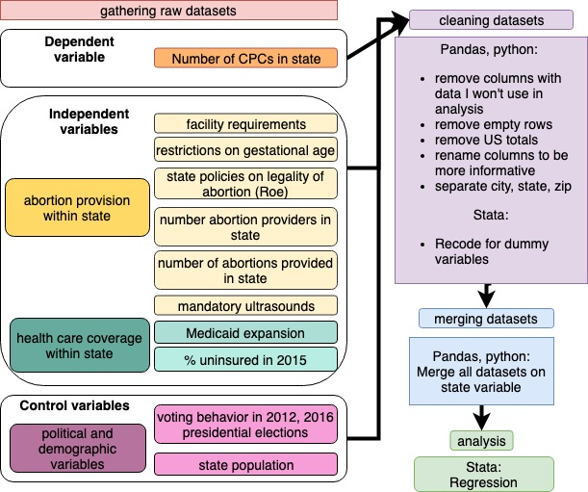

**Appendix B: Data dictionary**

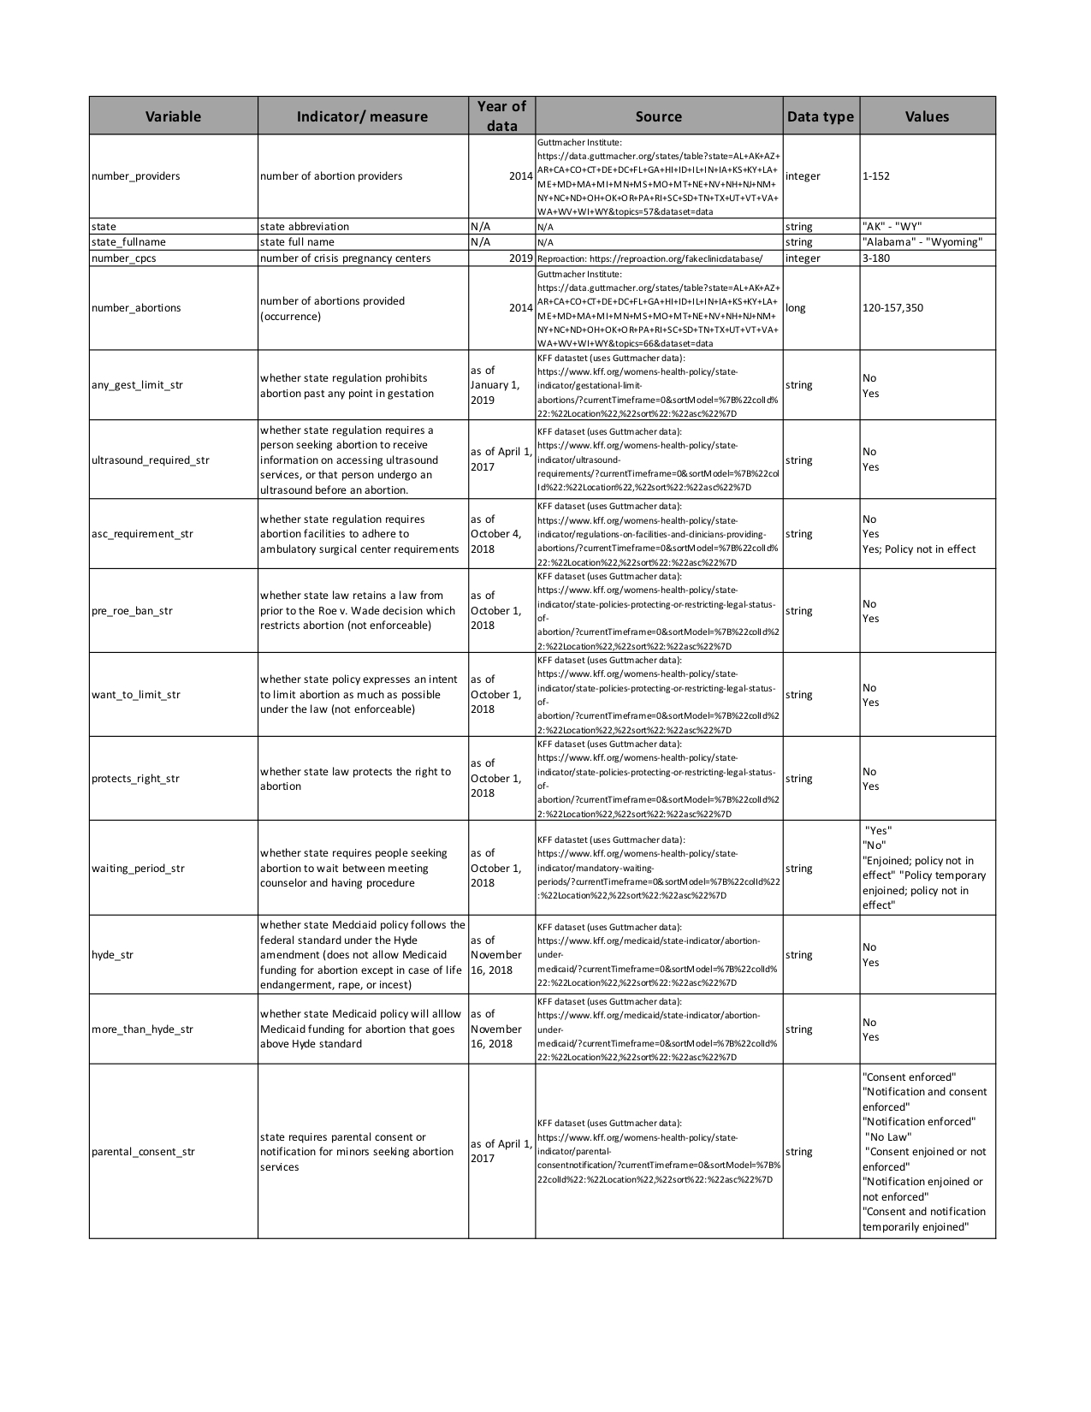

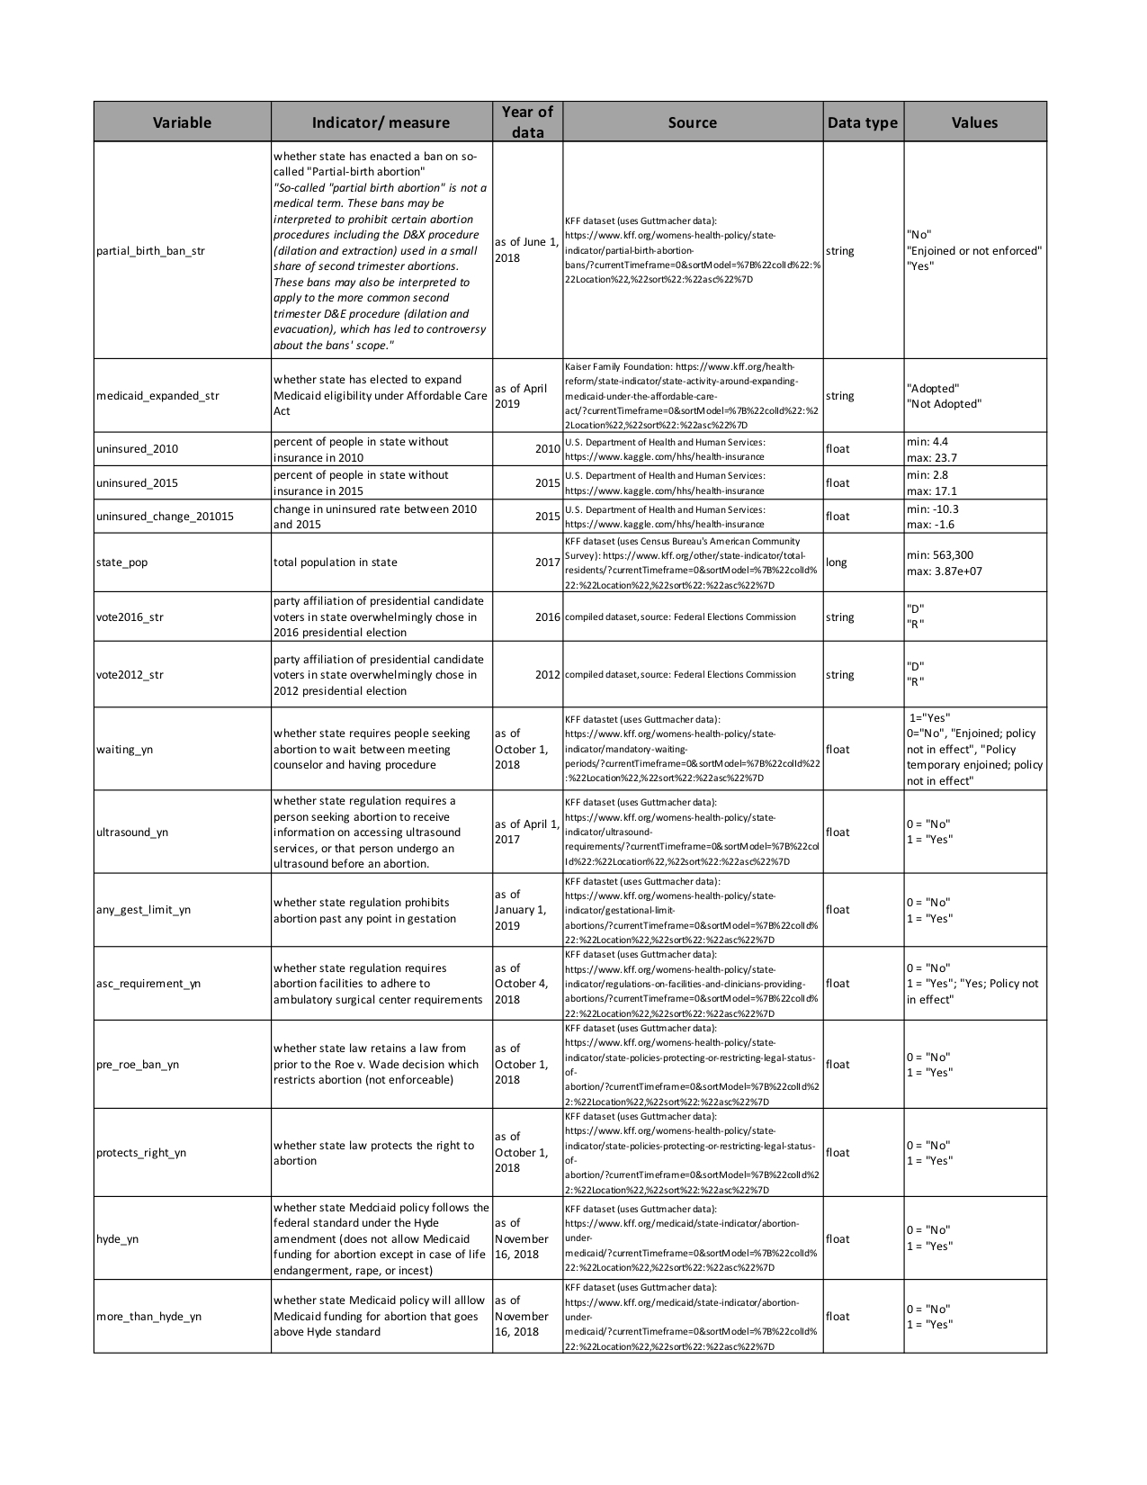

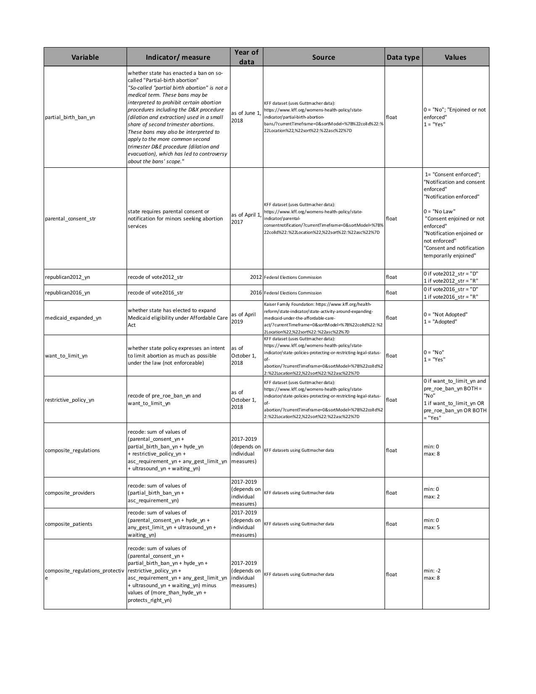

**Appendix C: Data management plan**

# Predicting the Number of Crisis Pregnancy Centers by State

### Data Collection

*What data will you collect or create?*

I will collect open access datasets available from the following sources:

* percent of people uninsured by state (from US HHS/Kaggle, available here: <https://www.kaggle.com/hhs/health-insurance>)
* whether or not states have expanded Medicaid (from KFF: <https://www.kff.org/health-reform/state-indicator/state-activity-around-expanding-medicaid-under-the-affordable-care-act/?currentTimeframe=0&sortModel=%7B%22colId%22:%22Location%22,%22sort%22:%22asc%22%7D>)
* total number of residents by state (from KFF via Census: <https://www.kff.org/other/state-indicator/total-residents/?currentTimeframe=0&sortModel=%7B%22colId%22:%22Location%22,%22sort%22:%22asc%22%7D>)
* number of abortion providers by state (using Guttmacher Institute data: <https://data.guttmacher.org/states>)
* number of abortions provided by state (using state of occurrence, not state of residence) (from Guttmacher Institute data: <https://data.guttmacher.org/states>)
* data on abortion restrictions (whether state has any prohibition on abortion past any point in gestation, whether state requires a person to receive information on ultrasounds or undergo an ultrasound, whether state requires abortion facilities to adhere to ambulatory surgical center requirements, whether state policy protects or restrict right to abortion, whether state has a required waiting period before abortion, whether state allows use of Medicaid funds to pay for abortion, whether state requires parental consent for abortion, whether state has a so-called "partial birth" ban) - all come from KFF's Stata Data portal: <https://www.kff.org/state-category/womens-health/> using Guttmacher Institute data
* state population (from KFF dataset using Census Bureau's American Community Survey data: https://www.kff.org/other/state-indicator/total-residents/?currentTimeframe=0&sortModel=%7B%22colId%22:%22Location%22,%22sort%22:%22asc%22%7D)
* state voting behavior in 2012 and 2016 (compiled from Federal Election Commission data: <https://transition.fec.gov/pubrec/fe2016/federalelections2016.pdf> and [https://transition.fec.gov/pubrec/fe2012/federalelections2012.pdf)](https://transition.fec.gov/pubrec/fe2016/federalelections2016.pdf)
* number of crisis pregnancy centers by state (from Reproaction: https://reproaction.org/fakeclinicdatabase/)

*How will the data be collected or created?*

The data is all open source, but I will use Python and pandas to clean the datasets. I will be removing empty rows and removing columns not used for analysis. From the CPC database, I isolate the state variable from their column (since city, state, and zip are all together in the same column) and then restructure the data so that each state is associated with the count of unique CPCs in that state. From there, I will merge all datasets on the state variable, and then rename the columns of the final merged dataset for clarity.

### Documentation and Metadata

*What documentation and metadata will accompany the data?*

The variables will be clearly labeled, using underscores (_) to separate words in variable titles. String variables, from the original datasets, will have _str appended to their label, while dummy variables (0 for No and 1 for Yes) will have _yn appended to their data label.

### Ethics and Legal Compliance

*How will you manage any ethical issues?*

All of the data are secondary data, so all should have gone through an ethical review board process before collection. All of the data is aggregated at the state level, so it is anonymous and de-identified.

*How will you manage copyright and Intellectual Property Rights (IP/IPR) issues?*

All of the data are open source and available on the Internet.

### Storage and Backup

*How will the data be stored and backed up during the research?*

I will store the data on my computer. I backed up the data on my Google drive and sync the backup weekly.

*How will you manage access and security?*

I am working alone so do not need to ensure access for collaborators. My computer is password-protected.

### Selection and Preservation

*Which data are of long-term value and should be retained, shared, and/or preserved?*

The data are all backed up on the websites which hosted them originally, but I will keep my dataset available through my GitHub account, <https://github.com/marjoriecrowell/Data-mgmt/tree/master/Final%20project>

.

*What is the long-term preservation plan for the dataset?*

I will retain the data on my Google Drive and my GitHub moving forward.

### Data Sharing

*How will you share the data?*

My data will be available on my GitHub account (<https://github.com/marjoriecrowell/Data-mgmt/tree/master/Final%20project>

) for anyone to use. Because my data is all open source, I do not have any proprietary ownership over the data. My code will also be available on my GitHub (<https://github.com/marjoriecrowell/Data-mgmt/tree/master/Final%20project>

) so that it will be replicable.

*Are any restrictions on data sharing required?*

no restrictions required.

### Responsibilities and Resources

*Who will be responsible for data management?*

I am responsible for data management and will be implementing the DMP. I will be reassessing my data management plan weekly throughout the project to make sure that I am adhering to it and to check if there are any edits I need to make.

*What resources will you require to deliver your plan?*

I will require GitHub and Google Drive accounts and repositories.

1. Collaborative Group on Hormonal Factors in Breast Cancer, “Breast Cancer and Abortion: Collaborative Reanalysis of Data from 53 Epidemiological Studies, Including 83 000 Women with Breast Cancer from 16 Countries,” *The Lancet* 363, no. 9414 (March 27, 2004): 1007–16, https://doi.org/10.1016/S0140-6736(04)15835-2; M Antonia Biggs et al., “Does Abortion Increase Women’s Risk for Post-Traumatic Stress? Findings from a Prospective Longitudinal Cohort Study,” *BMJ Open* 6, no. 2 (February 1, 2016), https://doi.org/10.1136/bmjopen-2015-009698.
2. Katrina Kimport, J. Parker Dockray, and Shelly Dodson, “What Women Seek from a Pregnancy Resource Center,” *Contraception* 94, no. 2 (2016): 168–72, https://doi.org/10.1016/j.contraception.2016.04.003.
3. Amy G. Bryant and Jonas J. Swartz, “Why Crisis Pregnancy Centers Are Legal but Unethical,” *AMA Journal of Ethics* 20, no. 1 (March 1, 2018): 269–77, https://doi.org/10.1001/journalofethics.2018.20.3.pfor1-1803.
4. Rewire.News, “Crisis Pregnancy Centers,” Rewire.News, accessed April 17, 2019, https://rewire.news/legislative-tracker/law-topic/crisis-pregnancy-centers/.
5. Katelyn Bryant-Comstock et al., “Information about Sexual Health on Crisis Pregnancy Center Web Sites: Accurate for Adolescents?,” *Journal of Pediatric and Adolescent Gynecology* 29, no. 1 (February 2016): 22–25, https://doi.org/10.1016/j.jpag.2015.05.008.
6. D. Tsevat, J. Miracle, and M. Gallo, “Evaluation of Services at Crisis Pregnancy Centers in Ohio,” *Contraception* 94, no. 4 (October 1, 2016): 391–92, https://doi.org/10.1016/j.contraception.2016.07.037.
7. Kimport, Dockray, and Dodson, “What Women Seek from a Pregnancy Resource Center.”
8. NARAL Pro-Choice America, “The Truth about Crisis Pregnancy Centers,” January 1, 2017, https://www.prochoiceamerica.org/wp-content/uploads/2016/12/6.-The-Truth-About-Crisis-Pregnancy-Centers.pdf.
9. Andrew Yuengert and Joel Fetzer, “Location Decisions of Abortion Clinics and Crisis Pregnancy Centers in California,” *Catholic Social Science Review* 15 (July 1, 2010): 211–35, https://doi.org/10.5840/cssr20101513.
10. Elizabeth Nash et al., “Policy Trends in the States, 2017” (New York: Guttmacher Institute, January 2, 2018), https://www.guttmacher.org/article/2018/01/policy-trends-states-2017.
11. Rachel K. Jones and Jenna Jerman, “Abortion Incidence and Service Availability In the United States, 2014: Abortion Incidence and Service Availability In the United States, 2014,” *Perspectives on Sexual and Reproductive Health* 49, no. 1 (March 2017): 17–27, https://doi.org/10.1363/psrh.12015; Alice F. Cartwright et al., “Identifying National Availability of Abortion Care and Distance From Major US Cities: Systematic Online Search,” *Journal of Medical Internet Research* 20, no. 5 (2018): e186, https://doi.org/10.2196/jmir.9717.
12. Cartwright et al., “Identifying National Availability of Abortion Care and Distance From Major US Cities.”
13. Rewire.News, “Crisis Pregnancy Centers.”
14. Alliance Defending Freedom, “Austin LifeCare v. City of Austin,” Default, accessed April 17, 2019, http://adflegal.org/detailspages/case-details; Alliance Defending Freedom, “Pregnancy Care Center of New York v. City of New York,” Default, accessed April 17, 2019, http://adflegal.org/detailspages/case-details; Ian Duncan, “Federal Appeals Court Rules against Baltimore Law Requiring Disclosures at Pregnancy Clinics That Don’t Provide Abortions,” *Baltimore Sun*, January 5, 2018, https://www.baltimoresun.com/health/bs-md-ci-pregnancy-clinic-ruling-20180105-story.html.
15. Beth Holtzman, “Have Crisis Pregnancy Centers Finally Met Their Match: California’s Reproductive FACT Act,” *Northwestern Journal of Law & Social Policy* 12, no. 3 (2017); Madeline Wetterhahn and Marcia Boumil, “US Supreme Court Strikes Down California FACT Act | Health Affairs,” Health Affairs, June 29, 2018, https://www.healthaffairs.org/do/10.1377/hblog20180628.429780/full/; “Bill Text - AB-775 Reproductive FACT Act.,” accessed April 17, 2019, https://leginfo.legislature.ca.gov/faces/billNavClient.xhtml?bill_id=201520160AB775.
16. Nash et al., “Policy Trends in the States, 2017.”
17. Theodore Joyce, “The Supply-Side Economics of Abortion,” *New England Journal of Medicine* 365, no. 16 (October 20, 2011): 1466–69, https://doi.org/10.1056/NEJMp1109889.
18. Jones and Jerman, “Abortion Incidence and Service Availability In the United States, 2014.”
19. Ibis Reproductive Health and Center for Reproductive Rights, “Evaluating Priorities: Measuring Women’s and Children’s Health and Well-Being against Abortion Restrictions in the States” (New York and Cambridge, MA: Center for Reproductive Rights and Ibis Reproductive Health, 2017), https://www.reproductiverights.org/sites/crr.civicactions.net/files/documents/USPA-Ibis-Evaluating-Priorities-v2.pdf.
20. “Abortion Policy in the Absence of Roe,” Guttmacher Institute, March 14, 2016, https://www.guttmacher.org/state-policy/explore/abortion-policy-absence-roe.
21. “Requirements for Ultrasound,” Guttmacher Institute, March 14, 2016, https://www.guttmacher.org/state-policy/explore/requirements-ultrasound.
22. “Counseling and Waiting Periods for Abortion,” Guttmacher Institute, March 14, 2016, https://www.guttmacher.org/state-policy/explore/counseling-and-waiting-periods-abortion.
23. “Parental Involvement in Minors’ Abortions,” Guttmacher Institute, March 14, 2016, https://www.guttmacher.org/state-policy/explore/parental-involvement-minors-abortions.
24. Caroline Rosenzweig and 2017, “The Hyde Amendment and Coverage for Abortion Services,” *The Henry J. Kaiser Family Foundation* (blog), October 16, 2017, https://www.kff.org/womens-health-policy/perspective/the-hyde-amendment-and-coverage-for-abortion-services/.
25. “Medicaid - HealthCare.Gov Glossary,” HealthCare.gov, accessed December 5, 2018, https://www.healthcare.gov/glossary/medicaid/.
26. Rosenzweig and 2017, “The Hyde Amendment and Coverage for Abortion Services.”
27. Reproaction Education Fund, “The Fake Clinic Database,” Reproaction, August 17, 2018, https://reproaction.org/fakeclinicdatabase/.
28. Reproaction Education Fund; “About Reproaction,” Reproaction, accessed April 18, 2019, https://reproaction.org/about/.
29. Jones and Jerman, “Abortion Incidence and Service Availability In the United States, 2014.”
30. Centers for Disease Control and Prevention, “CDCs Abortion Surveillance System FAQs,” January 16, 2019, https://www.cdc.gov/reproductivehealth/data_stats/abortion.htm.
31. Jones and Jerman, “Abortion Incidence and Service Availability In the United States, 2014.”
32. “The Fiscal Case for Medicaid Expansion | Commonwealth Fund,” accessed May 8, 2019, https://doi.org/10.26099/w12z-v017.
33. Larisa Antonisse et al., “The Effects of Medicaid Expansion under the ACA: Updated Findings from a Literature Review,” *The Henry J. Kaiser Family Foundation* (blog), March 28, 2018, https://www.kff.org/medicaid/issue-brief/the-effects-of-medicaid-expansion-under-the-aca-updated-findings-from-a-literature-review-march-2018/; Andis Robeznieks, “How Medicaid Expansion Has Improved Care Access, Outcomes,” American Medical Association, September 27, 2018, https://www.ama-assn.org/delivering-care/patient-support-advocacy/how-medicaid-expansion-has-improved-care-access-outcomes; “Status of State Action on the Medicaid Expansion Decision,” *The Henry J. Kaiser Family Foundation* (blog), April 9, 2019, https://www.kff.org/health-reform/state-indicator/state-activity-around-expanding-medicaid-under-the-affordable-care-act/.
34. “Status of State Action on the Medicaid Expansion Decision.”
35. U.S. Department of Health and Human Services, “Health Insurance Coverage,” Kaggle, accessed May 10, 2019, https://kaggle.com/hhs/health-insurance.
36. R. M. Blank, C. C. George, and R. A. London, “State Abortion Rates. The Impact of Policies, Providers, Politics, Demographics, and Economic Environment,” *Journal of Health Economics* 15, no. 5 (October 1996): 513–53.
37. Joyce, “The Supply-Side Economics of Abortion.”
38. Reproaction Education Fund, “The Fake Clinic Database”; NARAL Pro-Choice America, “The Truth about Crisis Pregnancy Centers.”